Thank you for supporting local cancer care through your sponsorship of the Seacoast Cancer 5K. Your generosity helps us make a big impact for cancer patients and their families right here in the Seacoast. We’ve put together this social media toolkit to help you spread the word about your sponsorship. We are grateful that you are part of the Seacoast Cancer 5K community!
First – please make sure you are following us on our social media pages and tag us in your posts:
Facebook: Seacoast Cancer 5K
How to Tag on Facebook: As you are typing the post, enter an “@” symbol followed by Seacoast Cancer 5K. A screen will pop-up and you will be able to tag the event. See example below.
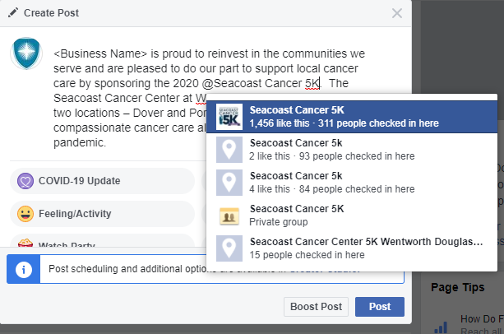
Instagram: wdhospital_nh and SeacoastCancer5K
How to Tag on Instagram: Before you post the photo there will be an option to “Tag People.” This option will show up in white text on the lower-left of the image. Click on this and then search “wdhospital_nh” and “SeacoastCancer5K.”
To tag us in the text, simple enter @wdhospital_nh and @SeacoastCancer5K. Nothing will pop-up but Instagram will tag us automatically.

LinkedIn: Wentworth-Douglass Hospital
As you are typing the post, enter an “@” symbol followed by Wentworth-Douglass Hospital. A screen will pop-up and you will be able to tag us by clicking on our name from a drop-down list (see example below).
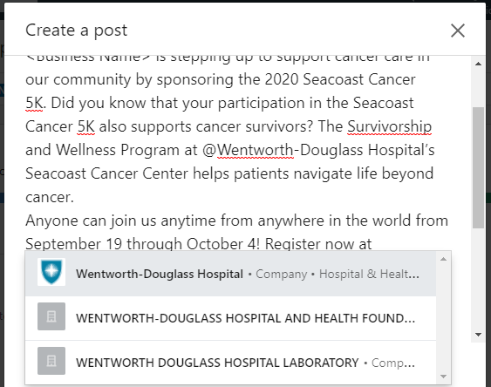
Please use the hashtag #SeacoastCancer5K to help us spread the word!

Suggested Social Media Posts
Sample Facebook Post 1:
<Business Name> is proud to reinvest in the communities we serve and are pleased to do our part to support local cancer care by sponsoring the 2020 @Seacoast Cancer 5K. The Seacoast Cancer Center at Wentworth-Douglass Hospital has two locations – Dover and Portsmouth, providing compassionate cancer care all year round – even during a pandemic.
The Race is Virtual. The Impact is Real. Join us anytime from September 19 through October 4. Register now at SeacoastCancer5K.org. #SeacoastCancer5K
Sample Facebook Post 2:
<Business Name> is stepping up to support cancer care in our community by sponsoring the 2020 Seacoast Cancer 5K. Did you know that your participation in the Seacoast Cancer 5K also supports cancer survivors? The Survivorship and Wellness Program at the Seacoast Cancer Center helps patients navigate life beyond cancer.
Anyone can join us anytime from anywhere in the world from September 19 through October 4! Register now at SeacoastCancer5K.org. #SeacoastCancer5K
Sample Facebook Post 3:
For this post, we recommend downloading the #WhyI5K printable tool on SeacoastCancer5K.org and asking your employees to complete these forms. You can pose for a socially distanced photo or ask your staff members to share fun “selfies” featuring their completed #WhyI5K sheets.
Cancer patients in our community need our support now more than ever. That’s why <Business Name> is sponsoring the 2020 @Seacoast Cancer 5K. The Seacoast Cancer Center at Wentworth-Douglass Hospital provides cancer treatment and resources to patients and families right here in the Seacoast.
Join us today by registering at SeacoastCancer5K.org and tell us Why YOU 5K! #SeacoastCancer5K

Sample Instagram Post 1:
<Business Name> is a proud to reinvest in the communities we serve and are pleased to support local cancer care by sponsoring the 2020 @SeacoastCancer5K. This important annual event supports lifesaving cancer care and programs for cancer patients and their families in our community at the Seacoast Cancer Center at @wdhospital_nh.
The Race is Virtual. The Impact is Real. Join us virtually anytime from September 19 through October 4.
Register now at SeacoastCancer5K.org. #SeacoastCancer5K
Sample Instagram Post 2:
<Business Name> is stepping up to support cancer care in our community by sponsoring the 2020 @SeacoastCancer5K. Participating in the Seacoast Cancer 5K also supports cancer survivors through the Seacoast Cancer Center’s Survivorship and Wellness Program.
Join us for the 2020 Seacoast Cancer 5K from September 19 through October 4! You pick the date, time, and place. Register now at SeacoastCancer5K.org. #SeacoastCancer5K
Sample Instagram Post 3
For this post, we recommend downloading the #WhyI5K printable tool on SeacoastCancer5K.org and asking your employees to complete these forms. You can pose for a socially distanced photo or ask your staff members to share fun “selfies” featuring their completed #WhyI5K sheets.
Today, <Business Name> spent time reflecting on #WhyWe5K to help us prepare for the 2020 @SeacoastCancer5K, an annual event to benefit the Seacoast Cancer Center.
Join us! Visit SeacoastCancer5K.org and tell us Why YOU 5K! #SeacoastCancer5K

Sample LinkedIn Post 1
<Business Name> is proud to reinvest in the communities we serve and are pleased to do our part to support local cancer care by sponsoring the 2020 Seacoast Cancer 5K. The Seacoast Cancer Center at @Wentworth-Douglass Hospital has two locations – Dover and Portsmouth, providing compassionate cancer care all year round – even during a pandemic.
The Race is Virtual. The Impact is Real. Join us anytime from September 19 through October 4.
Register now at SeacoastCancer5K.org. #SeacoastCancer5K
Sample LinkedIn Post 2
<Business Name> is stepping up to support cancer care in our community by sponsoring the 2020 Seacoast Cancer 5K. Did you know that your participation in the Seacoast Cancer 5K also supports cancer survivors? The Survivorship and Wellness Program at @Wentworth-Douglass Hospital’s Seacoast Cancer Center helps patients navigate life beyond cancer.
Anyone can join us anytime from anywhere in the world from September 19 through October 4! Register now at SeacoastCancer5K.org. #SeacoastCancer5K
Sample LinkedIn Post 3
For this post, we recommend downloading the #WhyI5K printable tool on SeacoastCancer5K.org and asking your employees to complete these forms. You can pose for a socially distanced photo or ask your staff members to share fun “selfies” featuring their completed #WhyI5K sheets.
Cancer patients in our community need our support now more than ever. That’s why <Business Name> is sponsoring the 2020 Seacoast Cancer 5K. The Seacoast Cancer Center at @Wentworth-Douglass Hospital provides cancer treatment and resources to patients, cancer survivors, and their families right here in the Seacoast.
Join us today by registering at SeacoastCancer5K.org and tell us Why YOU 5K! #SeacoastCancer5K

